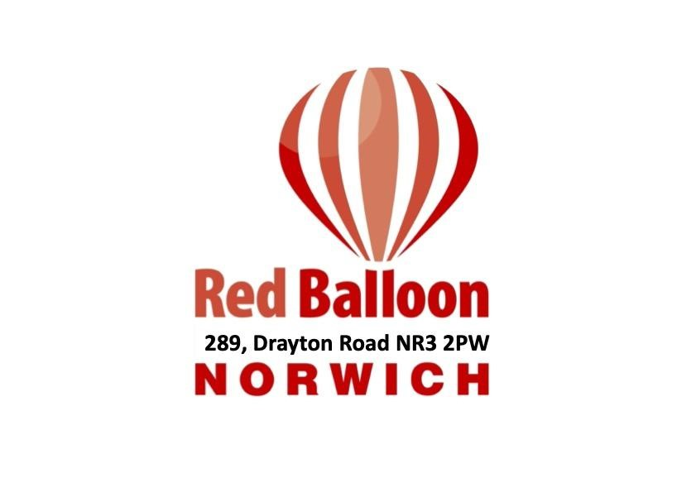
Red Balloon – Norwich
289 Drayton Road, Norwich, NR3 2PW
Email: mark.anderson@rbnorwich.org.uk
www.redballoonlearner.org.uk
Head of Centre: Mark Anderson
Registered Charity No. 1110792 Company Ltd by Guarantee
No. 566446
Job Description
Job Title | Learning Support Mentor (1 to 1 support)
Salary/Hours | Salary - £25,000.00- £27,000.00  Working hours are Mon- Fri 08:30 – 16:30 inc. lunchtimes.  This role is temporary until September 2026 (with the opportunity to become permanent)
Responsible to | Head of Centre
 |  | Role and Context
Job Purpose |  | The purpose of the role is to provide one to one intervention and support to an individual student who struggles with anxiety and required additional support. They have select mutism. The post holder will liaise with teaching staff, the Head of Centre, the SEN Manager and DSL team to ensure that their allocated student can access their full timetabled curriculum confidently. They will also communicate daily with parents and carers of the young person.  The Learning Support Mentor will provide support to their assigned student with catch up tutoring both in timetabled lessons and on a one to one basis and be a point of consistent support and reassurance allowing every opportunity for the young person to overcome what triggers their anxieties and fulfil their potential.
Context |  | The aim of the Red Balloon Learner Centre is:  - To provide a nurturing and supportive learning environment for students with or without an Education, Health and Care Plan who have suffered severe anxiety and significant trauma to the extent they are unable to access mainstream education.  - To offer a tailored blend of academic, vocational and wellbeing intervention to ensure each student can attend school regularly, access a full time education and make a positive career transition Post 16 once they leave Red Balloon Norwich.  Our team strives to enhance students' self-esteem, encouraging them to make key decisions and gradually taking control of their own learning. It is important that the jobholder acknowledges and is in agreement with our ethos.
Safeguarding |  | Safeguarding young people is the responsibility of everyone who works at Red Balloon Norwich. The post holder must agree to implement our practice in this area. The person appointed will be subject to a DBS Barred check.

Dimensions |  |  | Red Balloon Norwich offers places to a maximum of 40 students within the centre. All students have an EHCP in place to support their learning.
Relationships |  |  | Works closely with the Head of Centre, is part of the staff team, is a participating member of the Red Balloon community, and develops a good relationship with parents/carers and Trustees.
Other Job Information |  |  | Red Balloon and the Trustees will be accountable for all working arrangements and welfare provision.
 | Principal Accountabilities
1) | As a member of staff:  - To abide by and support the philosophy of Red Balloon Norwich  - To act as a both a tutor and mentor to the student supported  - To cooperate with the other staff in the running of the Centre as an active member of the team including breaks and lunchtimes;  - To attend INSET sessions  - To give feedback to parents/carers  - To ensure the RBN Safeguarding Policy is upheld and issues reported on MyConcern:  - To identify your personal and professional development needs related supporting students with additional SEN needs and who are anxious about learning.
Person Specification
 |  | Essential |  | Desirable
Qualifications |  | Relevant experience mentoring/work with vulnerable children.  5 GCSE’s grades 4-9 including English and Maths as a minimum. |  | Experience working with young people in a SEMH setting and/or willingness to undertake further training at Level 3 or above.
Skills/Knowledge |  | Understanding of mental health needs as well as the impact of bullying and social exclusion on young people.  Ability to communicate  well with students, staff, parents and carers.  Willingness to understand safeguarding processes and procedures.  Be organised and show initiative  Driving License and ability to drive is essential |  | Understanding of how to support young people with Mental Health Difficulties  Understanding of how to  promote and manage good attendance  Good use of ICT to enhance learning and assessment  Familiarity with electronic  databases and  Management Information  Systems

Experience | Willingness to support young people with SEND and catering for their learning needs |  | Supporting young people with medical needs or willingness to complete relevant training.
General Information
Red Balloon is a registered charity providing education for boys and girls and is committed to safeguarding and promoting the welfare of children. All staff are expected to share and support this commitment and applicants must be willing to undergo child protection screening appropriate to the post, including checks with past employers and the Disclosing and Barring Service.
The job specification details the main outcomes required and should only be updated to reflect major changes that impact on the outcomes for the job. Specific tasks, goals and performance criteria will be agreed through the Performance Management scheme.

All work performed/duties undertaken must be carried out in accordance with relevant Red Balloon philosophy, policies and procedures, within legislation, and with regard to the needs of students, staff and parents/carers.

Post holders will be expected to be flexible in their duties and carry out any other duties commensurate with the position and falling within the general scope of the job, as requested by Red Balloon.

